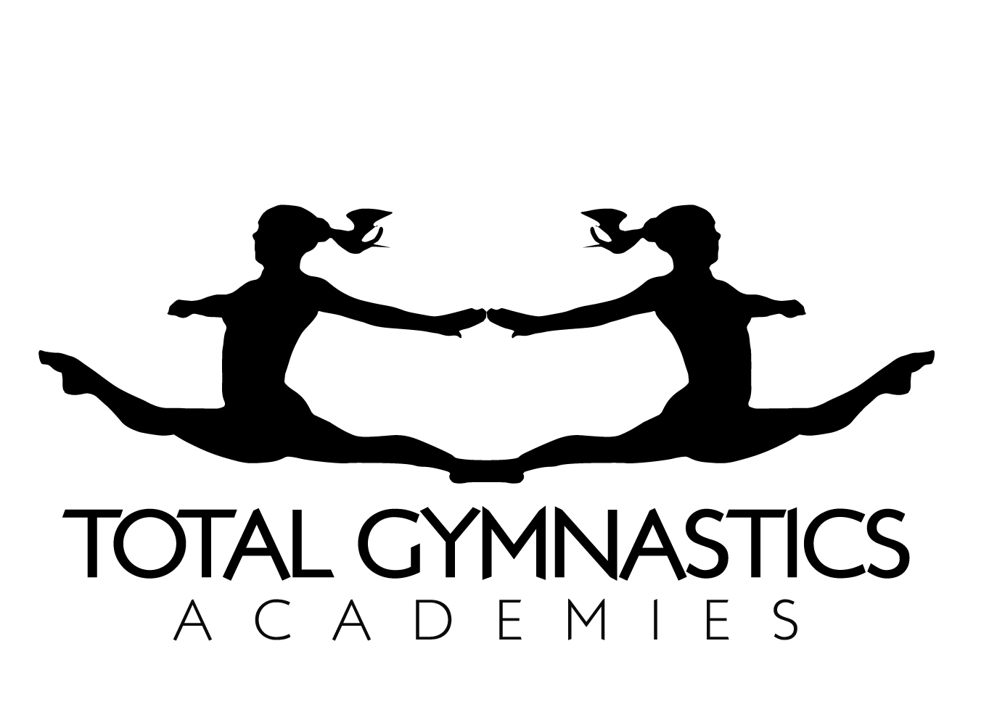
Job Title: Gymnastics Coach
Job reference: TGACHESHIREEAST2017
Employer: Total Gymnastics Academies LTD
Location: Wilmslow, Altrincham, Alderley Edge, Crewe

Total Gymnastics Academies is a dedicated company set up by Olympic Bronze Medallist, Beth Tweddle MBE to provide high quality, recreational gymnastics classes for children aged 2+ using a variety of rewards schemes and programmes. We currently have over 2200 gymnasts in our after school gymnastics academies and we teach up to 6500 school children with the national curriculum every week. The successful candidate will be working in a fast paced and exciting environment to deliver our aim of providing the opportunity for every child to have a go at gymnastics.

Reporting to: Regional co-ordinator

Summary of role: You will be providing high quality gymnastics coaching in a variety of environments including curriculum and after school gymnastics, to boys and girls aged 2 + under The Beth Tweddle Academy brand.

Specific responsibilities:

- Delivering high quality, safe, fun and structured recreational gymnastics classes to children aged 2+
- Keeping registers and contact details up to date
- Ensuring gymnast’s progression is up to date in progress booklets, online reports and online awards
- Ensuring school weekly reports are kept up to date to send to schools on a weekly basis
- Updating online systems with weekly and termly reports on each individual class
- Communicating with parents, teachers and coaches on a weekly basis within the lessons to ensure the lessons are of a high standard
- To undergo a training period to ensure the coach has full knowledge of our systems and programmes (approximately 2 ½ days)
- Acting as a mentor coach and a role model for younger and less experienced members of the team who are working through their coaching qualifications

Candidate profile:

- Exceptional organisation and time management skills
- Good at communicating with parents, gymnasts and fellow co-workers
- A great team player
- Confident and enthusiastic in their gymnastics provision
- Able to stay calm under pressure
- Comfortable dealing with enquiries or complaints from customers
- A desire to show initiative

Specific skills:

- UKCC Level 1 or 2 British Gymnastics Qualification
- Proficiency qualifications are also accepted
- Enhanced DBS check
- Safeguarding and Protecting Children Certificate
- First Aid qualification – preferably paediatric First Aid
- Competent user of IT systems including word and excel
- Good literacy skills
- Full driving licence is preferred but not required; if you do not hold a licence you must be able to access your venues of work using public transport

Salary and contract details:

- 10+ hours available depending on experience and availability
- Evening, weekday and weekend work required
- £10.00 - £15.00 per hour depending on qualification and experience
- You will be self-employed and responsible for your own tax, national insurance contribution and expenses.
- You must have access to the internet and Microsoft Word and Excel
- You will undertake a minimum training period of 2 ½ days before your contract begins to receive training on our systems and programmes
- Your line manager will meet with you every term to provide you with performance updates and any CPD opportunities
- Uniform is provided which must be worn to all classes
- Termly retention bonus for the strongest performing coaching team
- Coach of the Term and Coach of the Year awards
- Annual Black Tie High Performers Awards evening in December once you have worked for us for 1 year
- Development pathway available for coaches who want to move up to Lead Coach, Head Coach, Regional Co-Ordinator etc…

Application instructions:

- Send a copy of your CV with a covering letter to rachel.work@totalgymnastics.co.uk quoting the job reference TGACHESHIREEAST2017 References must be available on request.
- The successful candidate will be invited for a verbal and practical interview
- Closing date: We are always looking to recruit so there is no specific closing date on this advert, however we do have work available immediately

Contact:

- Web: www.totalgymnastics.co.uk
- Email: info@totalgymnastics.co.uk
- Phone: 0161 979 0611

Total Gymnastics Academies LTD are an equal opportunities employer and welcome applications from all suitably qualified persons regardless of their race, sex, disability, religion/belief, sexual orientation or age.

